



Essay / Assignment Title:
Leveraging Machine Learning Approaches for Stroke Risk Prediction
Programme title:
Introduction to Artificial Intelligence export
Name:
Mahla Alimardani, Q1107537
Year:
2025

CONTENTS
Chapters Pages
Introduction 4
Chapter One
Exploratory Data Analysis 5
Chapter Two
Data Preparation/ Model Training/ Model Evaluation and Visualization 13
Chapter Three
Conclusion and Future Work 35
Conclusion 38
References 39

Statement of compliance with academic ethics and the avoidance of plagiarism

I honestly declare that this dissertation is entirely my own work and none of its part has been copied from printed or electronic sources, translated from foreign sources and reproduced from essays of other researchers or students. Wherever I have been based on ideas or other people texts I clearly declare it through the good use of references following academic ethics.
(In the case that is proved that part of the essay does not constitute an original work, but a copy of an already published essay or from another source, the student will be expelled permanently from the program).

Name and Surname (Capital letters):

.................................MAHLA ALIMARDANI.....................................................................................................

Date: ..............09.........../.......29.../.......2025..

INTRODUCTION

When blood cannot reach a part of brain, a stroke will happen. It can make it hard for a person to hardly speech or move and even recovery may take a long time (NHS, n.d.). Stroke is the second common cause of death globally that cause 5.5 million deaths in 2015(Daidone, Ferrantelli and Tuttolomondo, 2023), also It has been found out that 90 percent of all strokes are due to modifiable risk factors, which include high blood pressure, obesity, physical inactivity, unhealthy diet as well as smoking. Thus, It is important to identify those people at high risk early to avert stroke and minimize complications. The latest developments that have been achieved in machine learning provide effective tools used in prediction of stroke risk based on analysis of complex trends in patient data. Through these computational methods, healthcare providers are able to introduce timely interventions and customize treatment plans and eventually enhance patient outcomes. The proposed project is based on the idea of using machine-learning models in order to predict the risk of stroke to offer a precise, data-driven method to assist with preventative healthcare.
The source files to all this project can be obtained through the following link.
https://github.com/mahlaalimardani/13711371

CHAPTER ONE
Exploratory Data Analysis
The major numeric variables will be age, avg_glucose_level, bmi, and the target variable will be stroke; the value of bmi has some missing values.
- Target (stroke)
The dataset is highly imbalanced. Predicting class 1 is harder, and plain accuracy can be misleading.
- Age
- Mean, median, min, and max for age is 43.2, 45, 0.08, 82.
Histogram and boxplot: large distribution throughout adulthood, median of 45, long tails. Age is probably a risk-causing factor that builds up. There is something strange with the very small minimum (newborn or data problem).
- Avg_glucose_level
- Mean = 106, std =45, min = 55, max =272.
Histogram: multi-modal: there are 1 large population with the centre near 80-100 and the other one with the center near 190-210. This means refers to various health profiles (high glucose vs normal). There is a good possibility that this variable would be a strong predictor.
- BMI
- BMI has Mean 28.9, SD 7.847, minimum value 10.3, maximum value 97.6, and some (NaN) values are missing.
Plot: skewed to the right having outliers. There are numerous individuals that are in overweight or obese ranges, they have extremes and they might correspond to uncommon events.
- Categorical snapshot (of the head)
Variables are hypertension, heart disease, ever married, work type, Residence type, work status. These provide both lifestyle and medical history and are able to interact with age and glucose.
- Overview
It is a binary classification dataset on a rare positive. Glucose has a high separation pattern, age indicates an increasing evidence in terms of risk, BMI is skewed and partially missing. Based on the visuals, we would anticipate by default that higher age, higher glucose, and higher BMI are more correlated with stroke and would be substantiated through modeling.

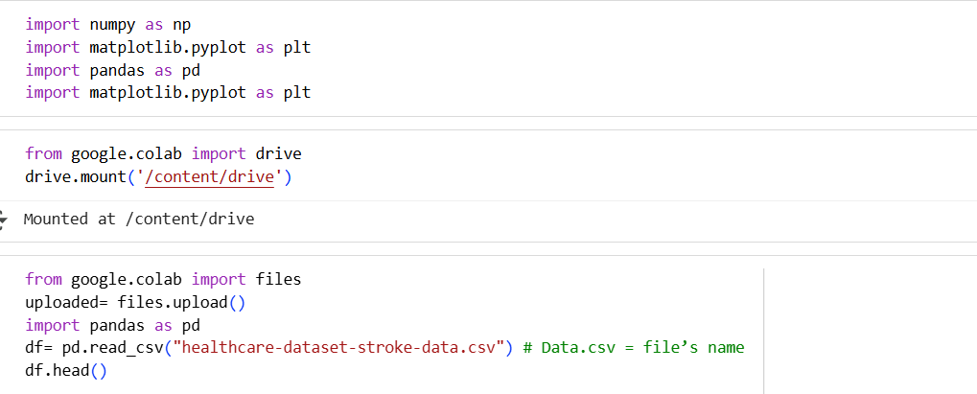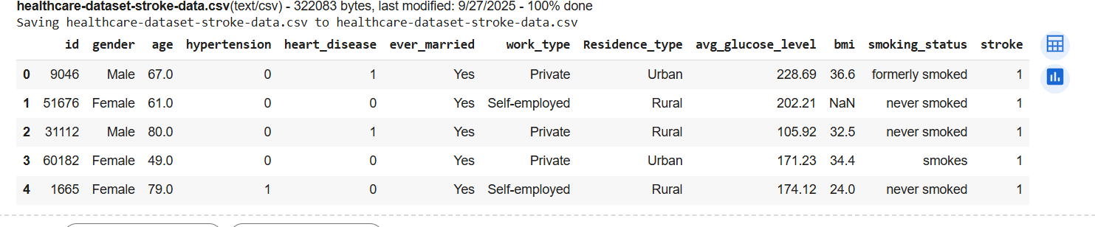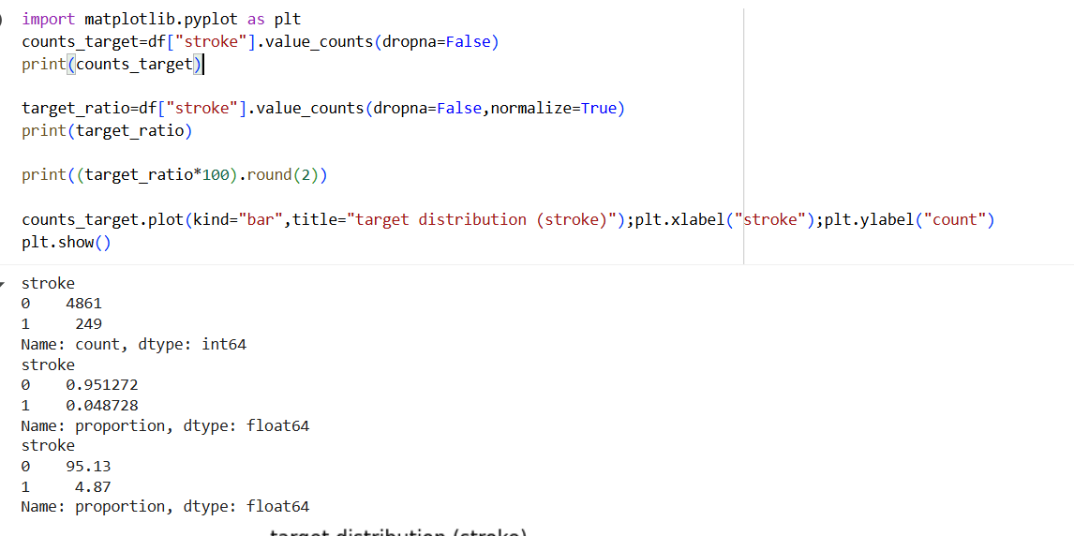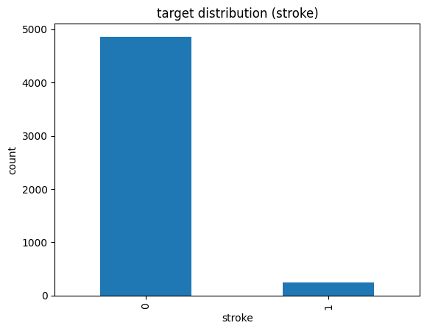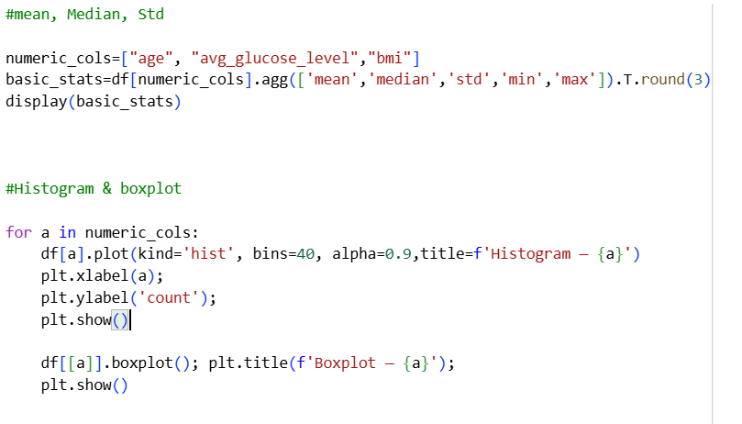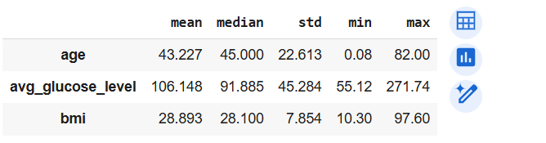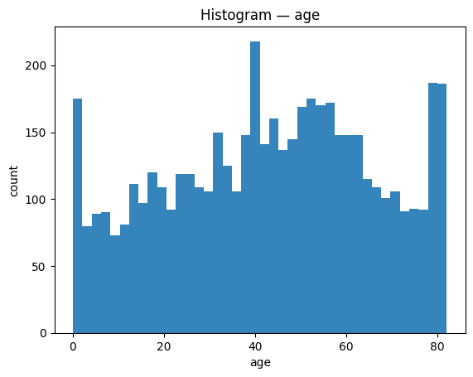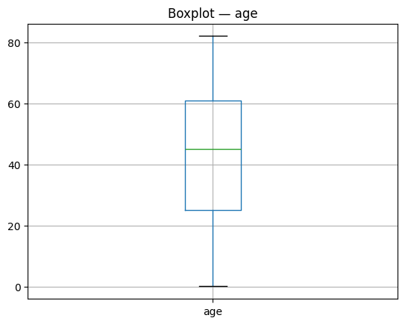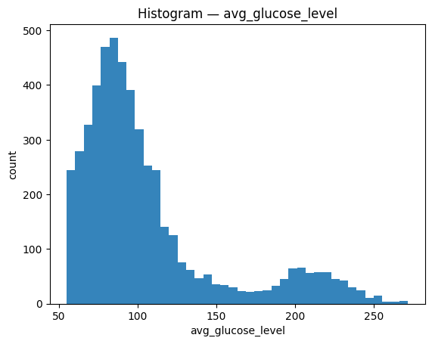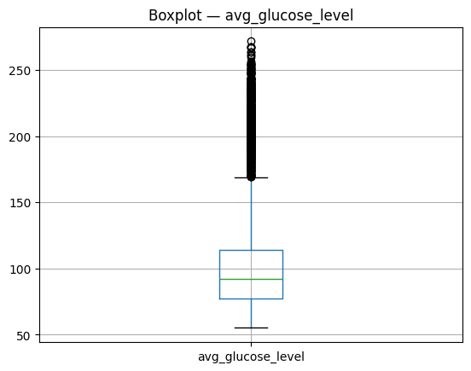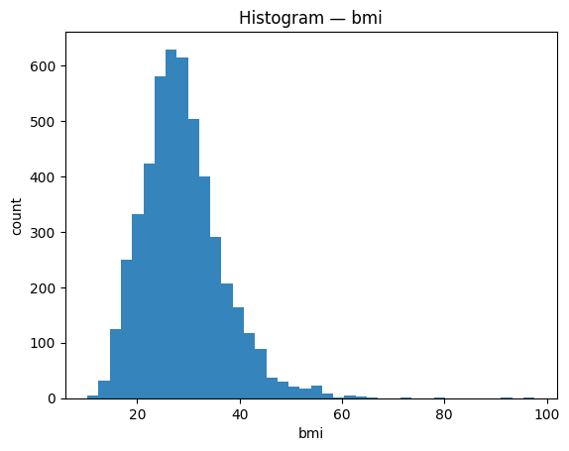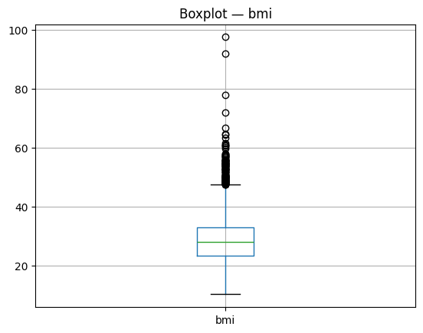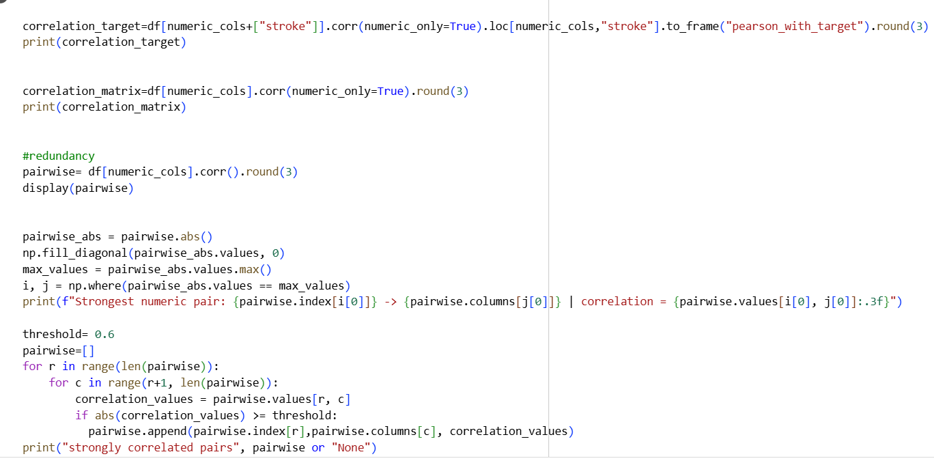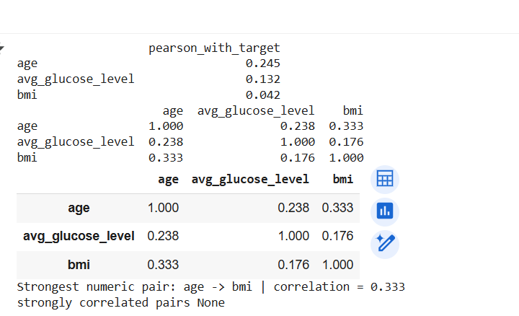

CHAPTER TWO
Data Preparation/ Model Training/ Model Evaluation and Visualization
Data Preparation:
There is not duplicated, only missing values can be seen in BMI, about 4% in row201.
Once the numeric columns were imputed using the mean and median and the categorical ones with the most common value, all the columns had reached 0% missing.
I cleaned and X to all columns except id and stroke and y to stroke. One-Hot Encoding was used to deal with categorical features whereas StandardScaler and SimpleImputer worked with numeric features. The feature space was expanded to 21 to validate the new encoded features.
Leakage prevention: Only fit transform was run on the training set and transform on the test set, assertions were then made that no missing values were left in the final matrices.
Split and class ratio: I split using 80 to 20 train and test split stratified using stratify=y (Train: 4088, Test: 1022) where the original class skews were maintained in the two groups.

The preprocessing pipeline can be easily connected to models such as Logistic Regression, SVM, Decision Tree, Random Forest, KNN. The data are in standard form and complete, and thus we can go to training and use class-imbalance techniques like class weight -balanced or oversampling.
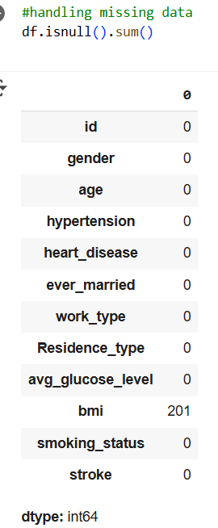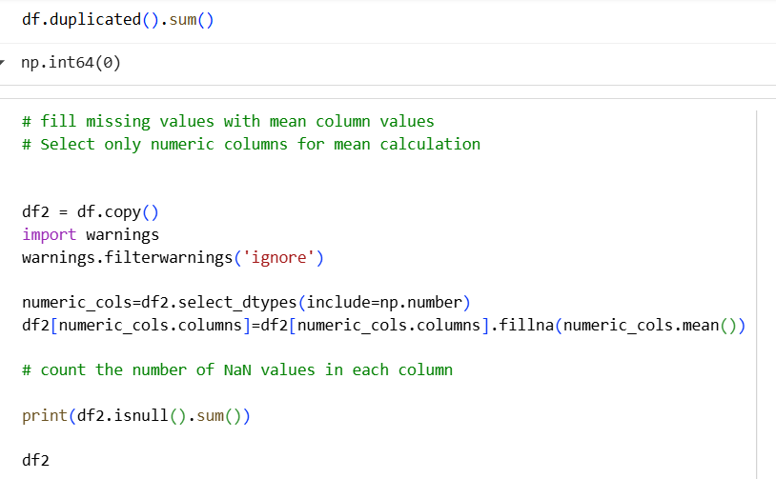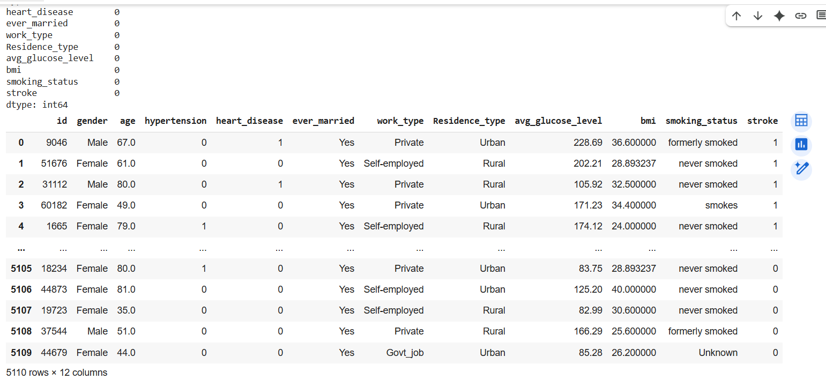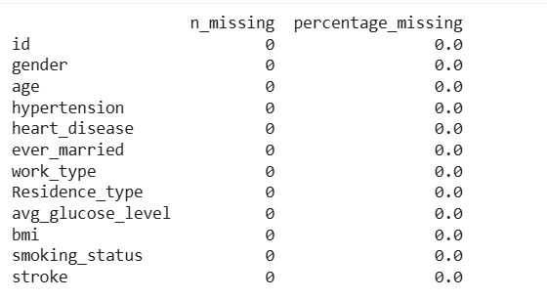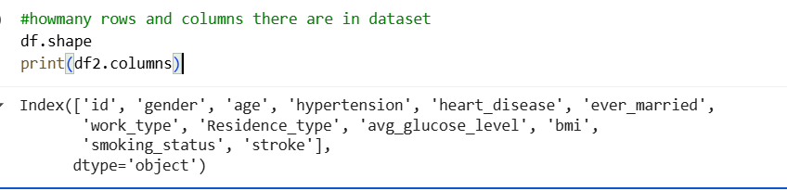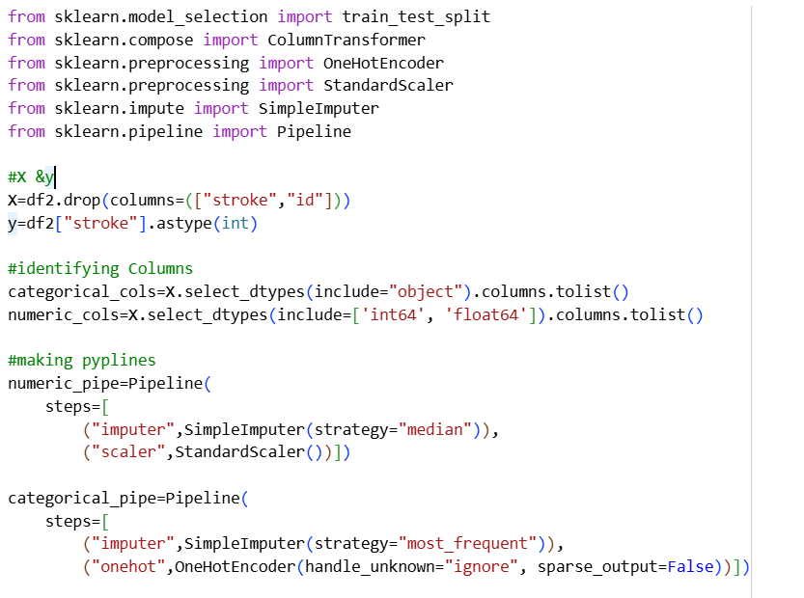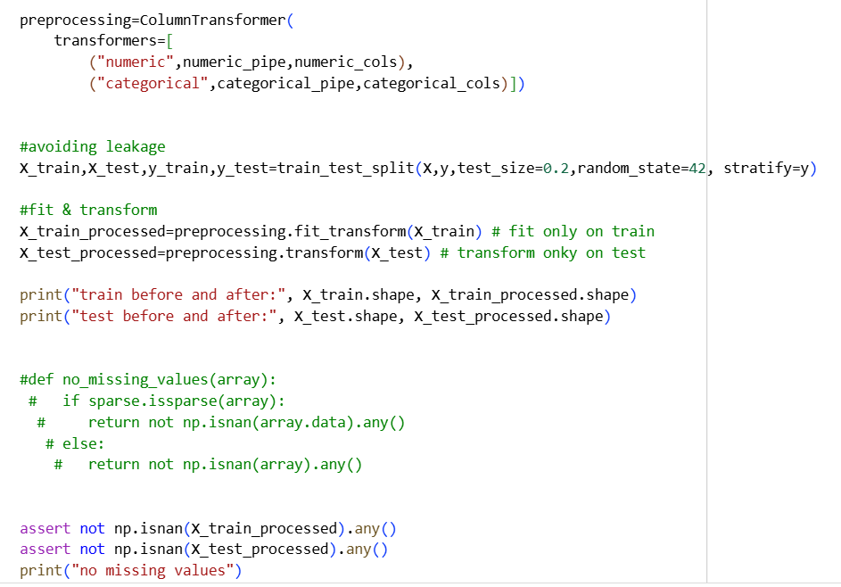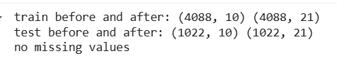
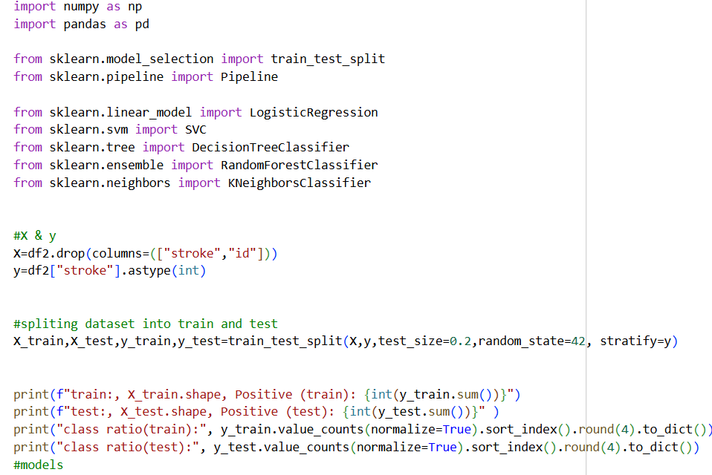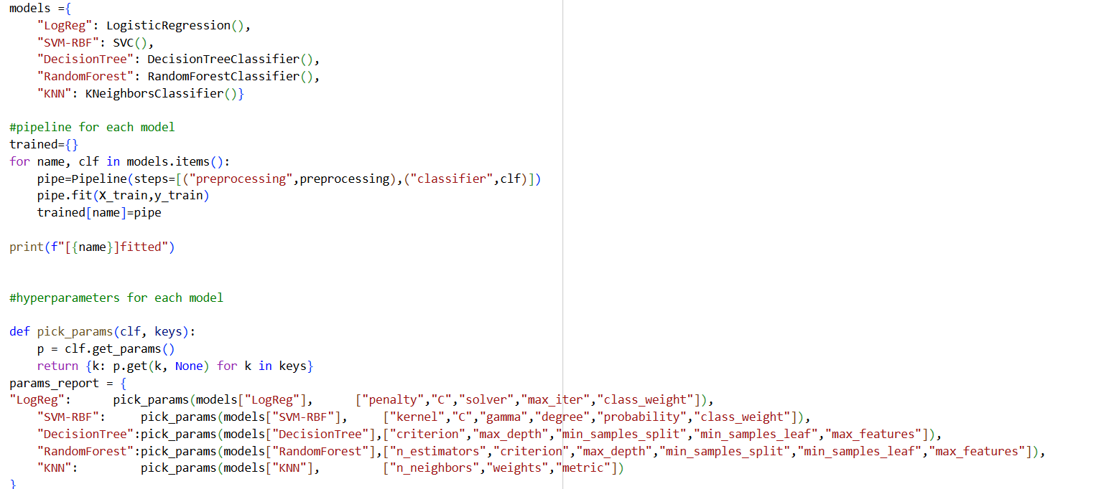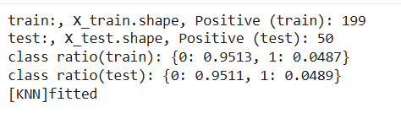

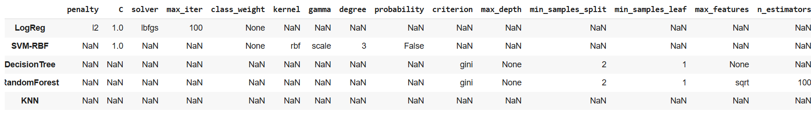

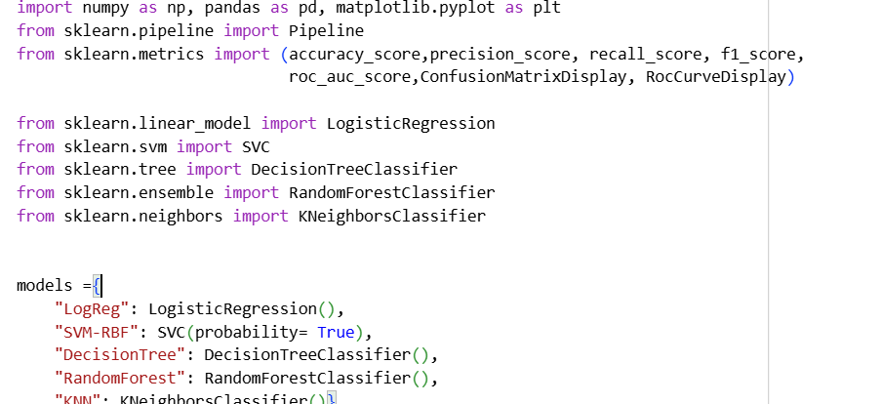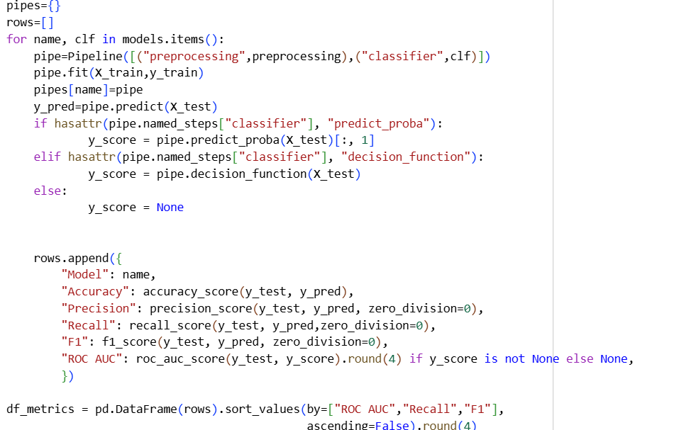

There were 5 models that were fitted in one pipeline and shared preprocessing; default hyperparameters were employed.
Splitting Imbalance: Train 4088, Test 1022 and a percentage of positives of about 5 and negative of about 95 in both sets- this has a strong effect on the metrics.
Test metrics table:
Most models have an accuracy of ≈ 0.95 (tree = 0.91), though this high accuracy is a demonstration of the majority class.
Most models have a recall of 0 0.02; nearly all of the positives are missed. The Decision Tree is the only that reaches Recall = 0.22, but with AUC = 0.58 and lower accuracy.
Precision LogReg gives a value of 1.0 since it makes only a single positive prediction, which was a correct prediction, the F1 remains very small (approximately 0.04.).
ROC-AUC has the best ranking, LogReg = -0.84 (good ranking ability) followed by the Random Forest = -0.79, the rest are smaller.
Confusion matrices:
LogReg: TN=972, FP=0, FN=49, TP=1 almost all positives were negatively predicted with default 0.5 level kills the recall.
SVM-RBF: TP=0, FN=50 that predicts the majority class on all cases.
ROC (LogReg): The curve is quite high above the diagonal (AUC ≈ 0.84), indicating that scores are informative, although by the threshold the binary classification does not find positives.
Overview: The default of most models is to the negative class due to the severe class imbalance. Although there are acceptable AUC of LogReg, Random Forest, Recall and F1 are quite low, and the confusion matrices indicate that positives are hardly detected.

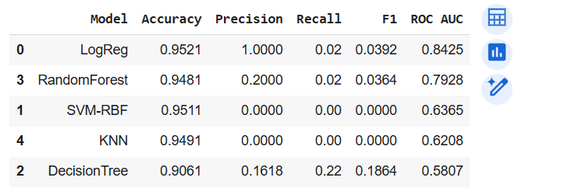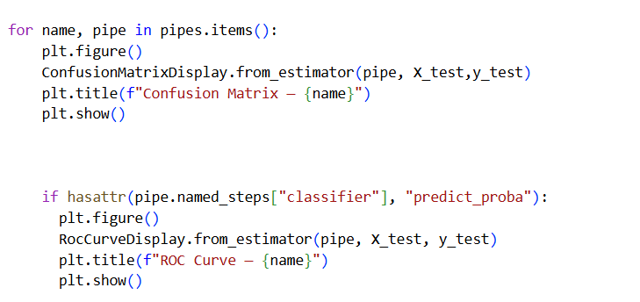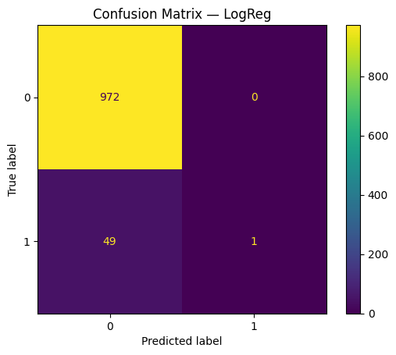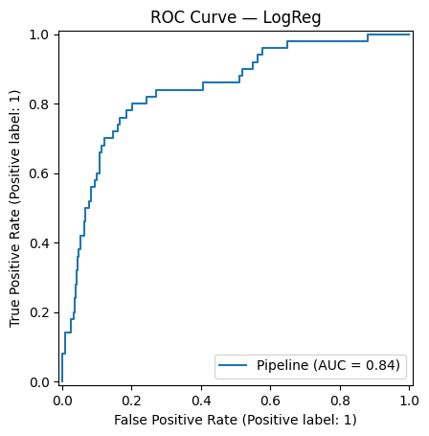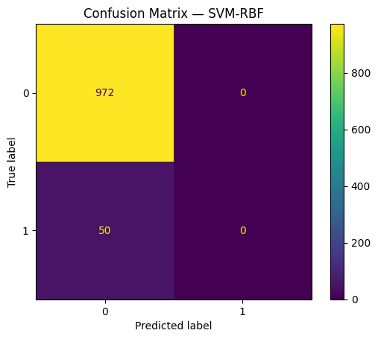

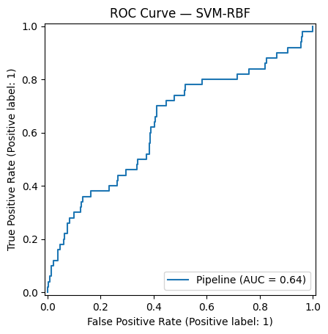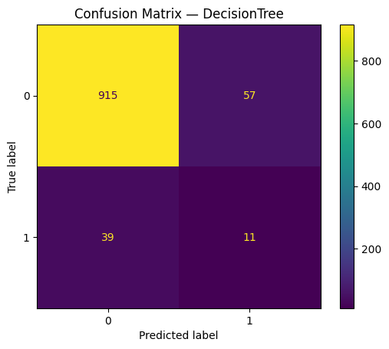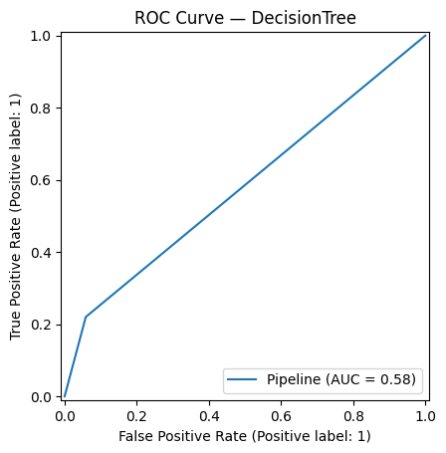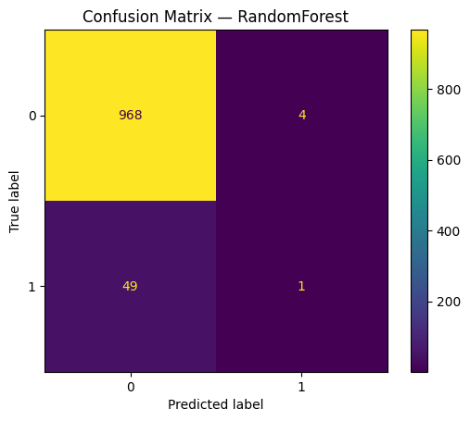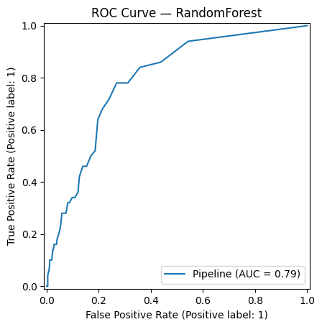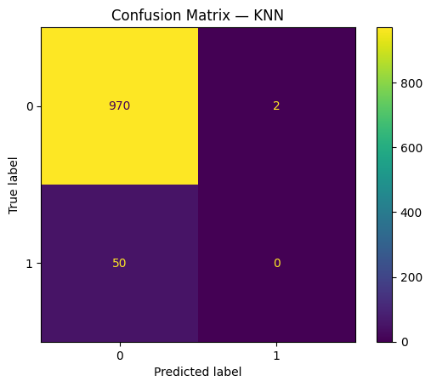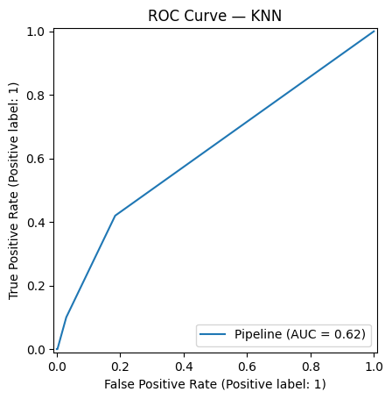

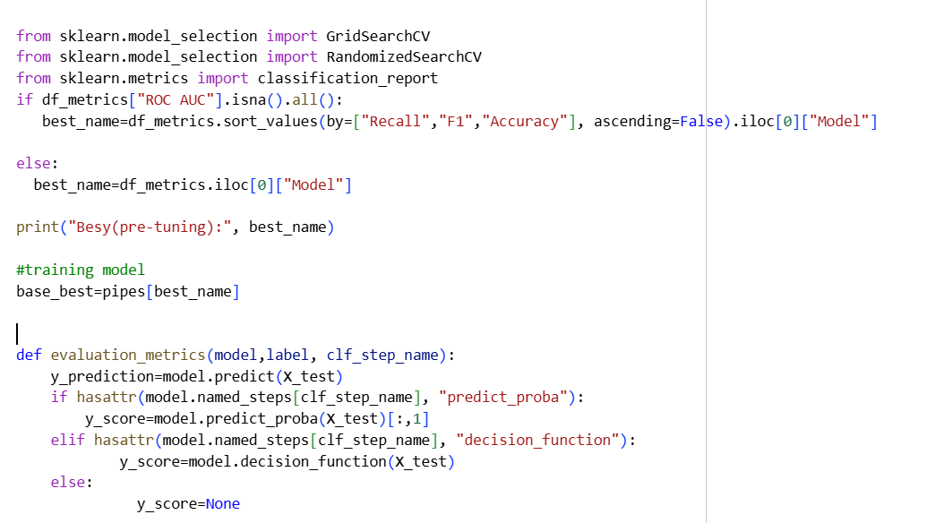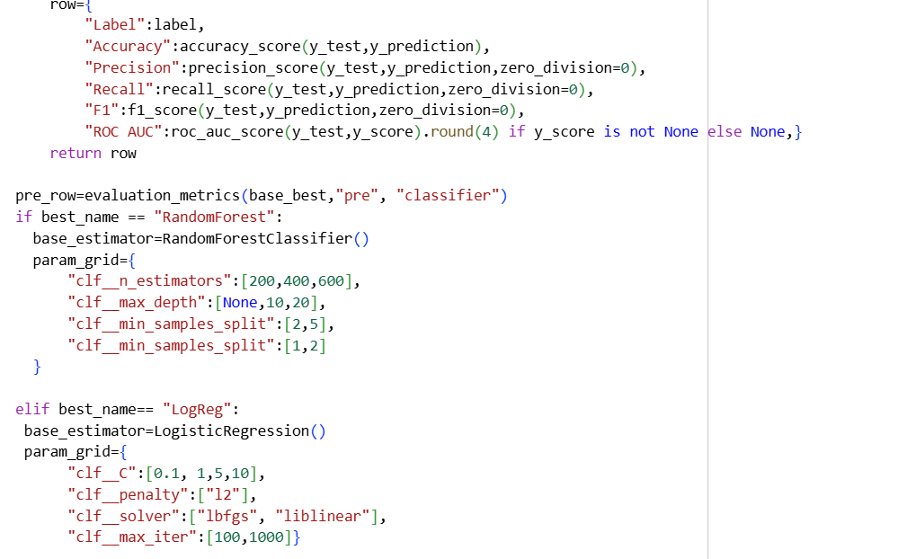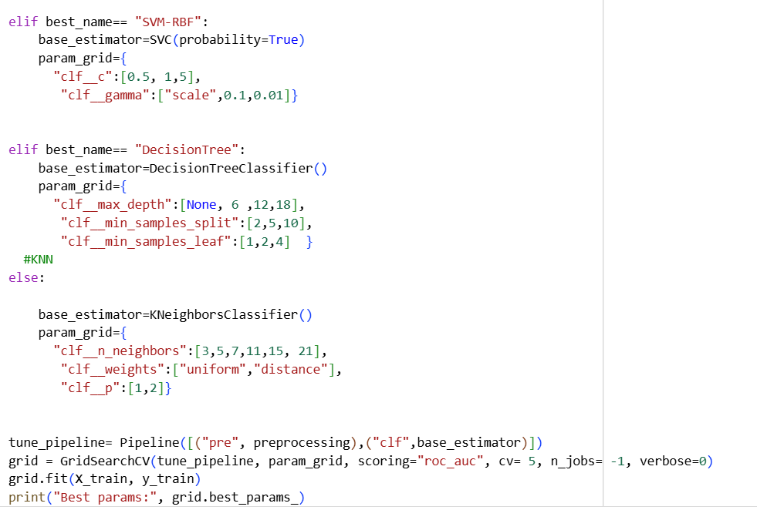
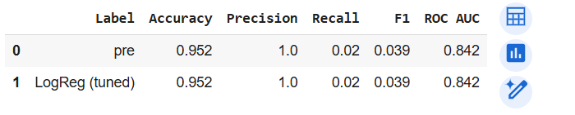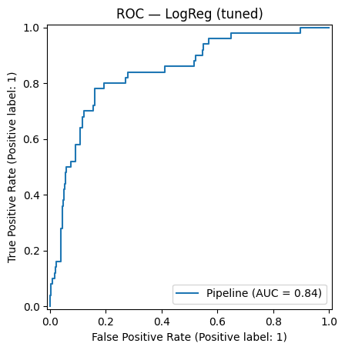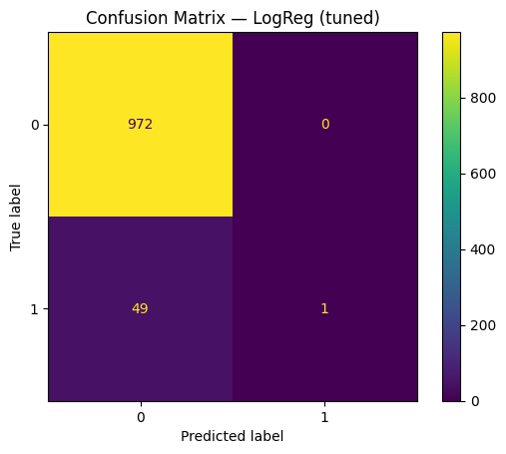
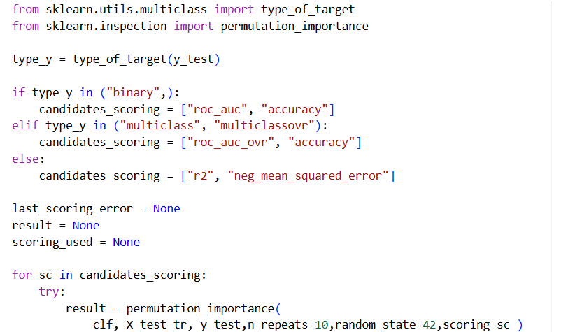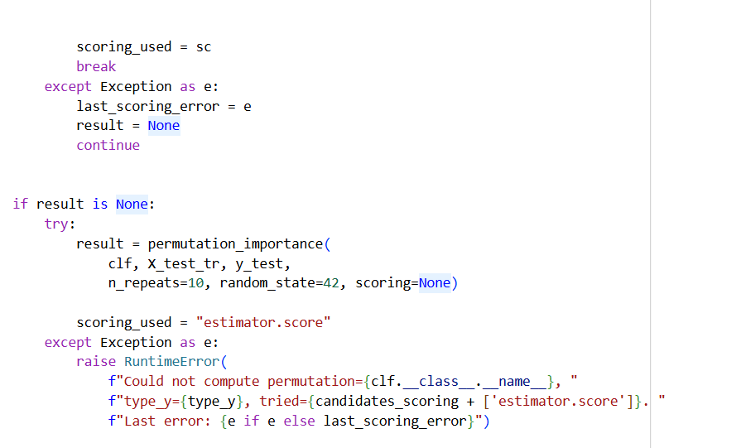
ROC — Logistic Regression (tuned): The curve lies on top of the diagonal with AUC = 0.84; there is no appreciable difference between the baseline and the tuned model-score ranking is good however.
Age, 0.29, that is the most influential feature. Average level glucose helpful to a small degree, hypertension and heart disease helpful to a small degree, bmi essentially non-helpful or is slightly negative.
The vast majority of categorical variables such as gender, work_type, smoking_status, residence_type, ever_married also have a near zero or even negative effect, which implies that they do not significantly enhance AUC in this model.
Overview: Tuned logistic model is dependent mainly on age other characteristics are insignificant. It is ranked ability good with high AUC, but the incremental information given by non-age variables is limited.
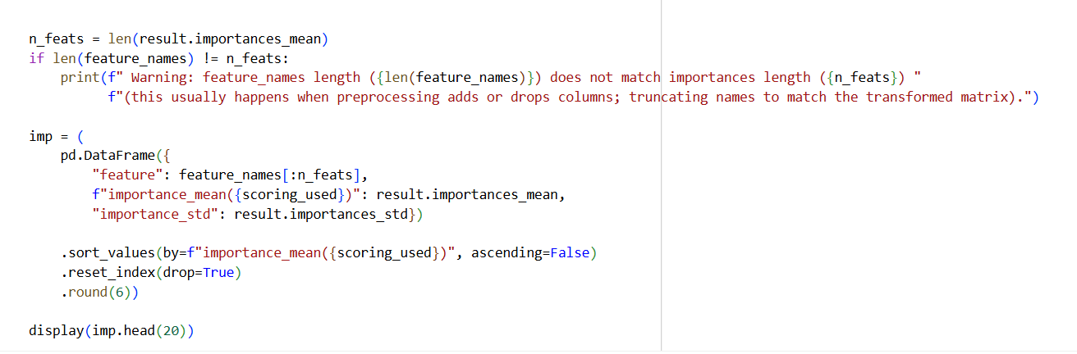
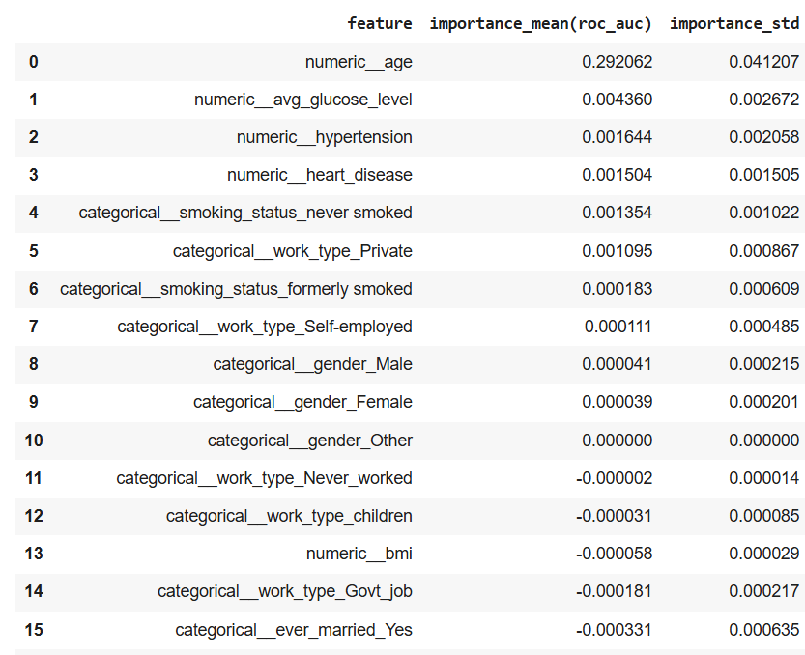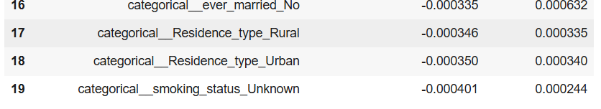

CHAPTER THREE
Future Work
Summary of Findings:
Best model:
The overall discrimination on the test set was the highest when using the Logistic Regression (ROC-AUC ≈ 0.842 0.843, Accuracy ≈ 0.952). Its operating point is however, very conservative (Precision = 1.00, Recall = 0.02, F1 = 0.039 ), meaning that it predicts very few positives. The tuned version basically did the same as the pre-tuned model and therefore no significant gains were realized by the existing tuning.
Key insights:
Permutation importance indicates a very strong concentrated signal: age is by far the most dominant predictor (ΔAUC 0.292 0.041), whereas avg_glucose level contributes a small, but significant signal (0.004), and other characteristics (hypertension, heart disease, work type, smoking status etc.) are not significant and are likely due to one-hot complements and class imbalance.
The model is reasonable in terms of aggregate (AUC) classification, but in the default 0.5 threshold, there are most positives that are missed (very low Recall). Threshold selection and imbalance control are both required in any application where false negatives are expensive.
Limitations
Class imbalance:
This may indicate that the minority class is being undetected at the default threshold.
feature representation:
One-hot, drop=first: Complementary columns are generated which dilute or mask importance; there are some categories which are exceptionally infrequent such as gender_Other.
Depending on one driver:
The high dependence on age makes issues of robustness when the age distribution of a target population changes.
External validity External or temporal validation:
The results are based on one dataset/population; external validity is necessary to make the claim of generalisability.

Future Work:
Decision threshold and metrics
- Optimize the decision threshold based on Youden J, cost-sensitive criteria or F1.
- Report PR-CAUC,precision and recall at the selected threshold, and cost-conscious measures, rather than ROC-AUC.
Imbalance handling:
Repeated stratified CV can prevent overfitting with use of class weight=balanced LogReg, and SVM or sampling algorithms (SMOTE and undersampling.
Feature engineering:
- One-hot enable drop = first: This encoding format collapses ultra-rare categories.
- Include clinically meaningful interactions for example, age x hypertension, age x avg_glucose level, mild non-linearities (age binning, and splines).
Models and tuning:
- Modern gradient boosting LightGBM, XGBoost, and CatBoost using Bayesian optimization Optuna or Skopt and, when suitable, monotonic constraints should be tried.
- Calibrate probabilities (Platt or isotonic) in order to have good thresholding.
Explainability and error analysis:
- Supplement permutation importance with SHAP (when using tree models) or PD and ICE plots to understand the effect of age and glucose on probability.
- Perform specific error analysis of false negatives in order to inform new features and threshold decisions.
Conclusion:
Logistic Regression is currently providing the most desirable discrimination (AUC) and it works at the point of unhelpfulness in terms of recall. The most obvious levers to increase real-world utility without reducing interpretability can be shifting the decision threshold, class imbalance, feature refinement and interaction refinement in particular and calibrated boosted models exploration.

CONCLUDING REMARKS

This project employed multiple classification models and machine learning models, including Decision Tree, Random Forest, and Support Vector Machine to predict stroke risks. Additionally, models were evaluated to identify the best-fit model for healthcare-dataset-stroke-data. Among numeric features, age shows the strongest link to stroke, while avg_glucose_level adds weaker but meaningful signal and has many high outliers Model performance was evaluated using metrics such as Accuracy, Precision, F1 Score, and Recall. The results show that the best model is Logistics Regression in terms of ROC and AUC, but not in terms of practical performance (F1 or Recall), that is expected with unusual data where PR measures are more revealing (Saito and Rehmsmeier ,2015). While XGBoost and LightGBM have higher performance and they are able to capture non-linear interaction in tabular healthcare data.(Chen and Guestrin, 2016).

BIBLIOGRAPHY

- NHS. (n.d.). Stroke. National Health Service. Available at: https://www.nhs.uk/conditions/stroke/ [Accessed 30 Sep. 2025]
- Daidone, M., Ferrantelli, S. and Tuttolomondo, A., 2023. Machine learning applications in stroke medicine: advancements, challenges, and future perspectives. Neural Regeneration Research, 19(4), pp.769-773. Available at: https://pmc.ncbi.nlm.nih.gov/articles/PMC10664112/ [Accessed 30 Sep. 2025]
- Saito, T. and Rehmsmeier, M. (2015) the precision-recall plot is more informative than the ROC plot when evaluating binary classifiers on imbalanced datasets, Plos One, 10(3), e0118432. Available at https://journals.plos.org/plosone/article?id=10.1371%2Fjournal.pone.0118432&utm_source [Accessed 30 Sep. 2025]
- Chen, T., Guestrin, C. (2016). XGBoost: A Scalable Tree Boosting System. In Proceedings of the 22nd ACM SIGKDD International Conference on Knwledge Discovery and Data Minig (KDD 16). New York: Available at https://dl.acm.org/doi/10.1145/2939672.2939785?utm_source [Accessed 30 Sep 2025]

APPENDIX (if necessary)

